Reinforcement Learning (RL):

🌟 What is Reinforcement Learning?
Reinforcement Learning is a branch of machine learning where an agent learns to make decisions by interacting with an environment. The agent takes actions, receives feedback (rewards or penalties), and gradually improves its behavior to maximize long-term rewards.
Unlike supervised learning (where the model learns from labeled data) or unsupervised learning (where it finds hidden patterns), RL is based on trial and error and sequential decision making.

🔑 Key Concepts
- Agent – the learner or decision-maker.
- Environment – the world the agent interacts with.
- State (s) – the current situation of the agent in the environment.
- Action (a) – a choice made by the agent.
- Reward (r) – feedback signal from the environment.
- Policy (π) – the strategy the agent uses to decide actions.
- Value Function (V or Q) – measures the long-term benefit of states or actions.
- Exploration vs Exploitation – balancing trying new actions (exploration) vs choosing the best-known action (exploitation).

⚙️ How It Works (Cycle of RL)
- Agent observes the current state.
- Agent takes an action based on its policy.
- Environment transitions to a new state and gives a reward.
- Agent updates its policy to maximize cumulative rewards.
- Repeat until learning converges.

📚 Popular RL Algorithms
- Q-Learning (value-based, model-free)
- SARSA
- Deep Q-Networks (DQN) (uses neural networks for large state spaces)
- Policy Gradient Methods
- Actor-Critic Methods (e.g., A3C, PPO, DDPG)

🎮 Real-World Applications
- Games & AI (Chess, Go, Atari, AlphaZero, OpenAI Five for Dota 2)
- Robotics (robot navigation, grasping)
- Autonomous Vehicles
- Recommendation Systems
- Finance & Trading
- Healthcare (treatment planning, drug discovery)

What is Passive Reinforcement Learning?
- Passive Reinforcement Learning is a type of RL where the agent follows a fixed policy (π) and learns about the environment without trying to improve the policy.
- In other words, the agent doesn’t actively explore different actions; instead, it executes the given policy and estimates values (state utilities or action values) to understand the consequences of that policy.

🔹 Key Features
- Policy is fixed – the agent does not choose new actions, only follows π.
- Learns state utilities – estimates how good it is to be in each state while following the policy.
- Environment model may or may not be known:
  - If the model is known → use Direct Evaluation.
  - If the model is unknown → use Temporal Difference (TD) learning or Monte Carlo methods.
- Goal is policy evaluation, not improvement.

🔹 Approaches in Passive RL
- Direct Utility Estimation (Monte Carlo)
  - Run episodes using the fixed policy.
  - Observe total returns (sum of rewards).
  - Average the returns for each state to estimate its utility.
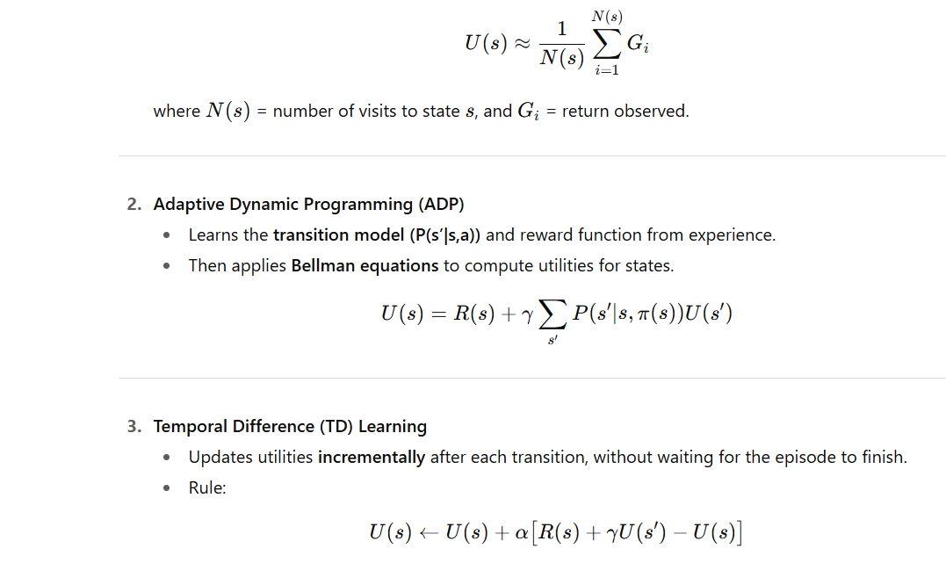
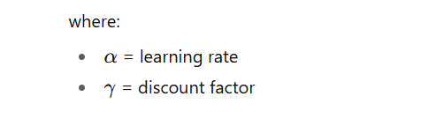
Example Scenario
Imagine a robot following a fixed path in a grid world:
- The policy says: “Always move right.”
- The robot doesn’t change this behavior.
- It records rewards and updates estimates of how good each state is under this policy.
🔹 Difference from Active RL
Aspect | Passive RL | Active RL
Policy | Fixed | Learned/Improved
Goal | Evaluate policy (state utilities) | Find optimal policy
Exploration | None (just follow π) | Yes (tries new actions)
Methods | Monte Carlo, TD, ADP | Q-learning, SARSA, Policy Gradient

Active Reinforcement Learning
Definition:
Active Reinforcement Learning (Active RL) is a type of reinforcement learning where an agent actively interacts with the environment to learn the best actions to take. Unlike passive RL, where the policy is fixed and the agent only evaluates it, in active RL the agent must both learn the policy (what to do) and the value function (how good it is).

Key Characteristics:
- Exploration vs. Exploitation:
  - The agent must balance between:
    - Exploration → trying new actions to discover their effects.
    - Exploitation → using known actions to maximize rewards.
- Policy Learning:
  - The agent doesn’t just evaluate; it improves its policy over time based on experience.
- Decision-Making:
  - At each state, the agent chooses the action based on its current knowledge, aiming for maximum cumulative reward.
- Trial-and-Error:
  - The agent experiments with different actions, observes outcomes, and updates its strategy.

Example:
- Game Playing (e.g., Chess or Pac-Man):
  - The agent does not know the best moves at the start.
  - It tries different moves (exploration).
  - Over time, it learns to choose better moves (exploitation) to maximize chances of winning.

Common Active RL Algorithms:
- Q-Learning (off-policy learning)
- SARSA (on-policy learning)
- Deep Q-Networks (DQN)
- Policy Gradient Methods

✅ In short:
Active RL = learning both the “what to do” (policy) and “how good it is” (value function) through exploration and exploitation while interacting with the environment.
Generalization in Reinforcement Learning (RL)
Generalization in reinforcement learning refers to the ability of an agent to apply knowledge learned from one set of experiences (training environments, states, or tasks) to new, unseen situations. Instead of memorizing specific actions for specific states, a well-generalizing RL agent can adapt its behavior in environments that differ from its training data.

🔹 Why Generalization is Important in RL
- Real-world applicability – Agents often face environments too large or complex to fully explore during training.
- Sample efficiency – Reduces the need for exploring every possible state.
- Robustness – Helps agents handle noise, uncertainty, and dynamic environments.
- Transfer learning – Knowledge gained in one task can improve performance in related tasks.

🔹 Types of Generalization in RL
- State Generalization
  - Learning to behave reasonably in states never explicitly visited during training.
  - Example: A robot trained to walk on flat ground should still walk on slightly uneven terrain.
- Task Generalization
  - Applying learned policies to new tasks.
  - Example: An agent trained to play Pong should adapt its knowledge to play Breakout.
- Environment Generalization
  - Performing well in new but similar environments with different dynamics.
  - Example: A self-driving car trained in one city should generalize to driving in another city.

🔹 Methods to Improve Generalization in RL
- Function Approximation
  - Neural networks (Deep RL) approximate value functions/policies across states.
- Regularization Techniques
  - Dropout, weight decay, entropy regularization prevent overfitting to training states.
- Data Augmentation
  - Varying training conditions (random textures, lighting, noise) makes policies robust.
- Domain Randomization
  - Randomizing environment parameters during training so the agent learns general rules.
- Transfer and Meta-Learning
  - Leveraging experience from multiple tasks to quickly adapt to new ones.
- Representation Learning
  - Learning abstract state representations (features) that capture general properties of the environment.

🔹 Challenges in Generalization
- Overfitting to training environments.
- Lack of diversity in training data.
- High variance in unseen tasks.
- Trade-off between exploration and generalization.

✅ In summary:
Generalization in RL is about moving from "memorizing experiences" to "understanding patterns" so the agent can act effectively in new, unseen, or dynamic situations. It is crucial for scaling RL from controlled lab settings to real-world applications.

Policy Search in Reinforcement Learning (RL):
Policy Search is an approach in reinforcement learning where the goal is to directly search for the best policy (a mapping from states to actions), instead of first learning a value function (like in value-based methods such as Q-learning).

🔑 Key Ideas:
- Policy Definition:
  - A policy (π) determines how an agent chooses actions based on the current state.
  - It can be deterministic (π(s) = a) or stochastic (π(a|s) = probability of action a in state s).
- Policy Parameterization:
  - Instead of representing policies explicitly, we parameterize them (e.g., using weights θ).
  - Example: πθ(a|s) could be represented using a softmax over linear functions of state features.
- Objective Function (Performance Measure):
  - The goal is to maximize the expected return:
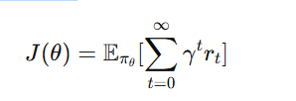
- Search Methods:
  - Gradient-Free Search: Uses optimization without gradients (e.g., evolutionary strategies, random search).
  - Policy Gradient Methods: Uses the gradient of J(θ) with respect to θ (e.g., REINFORCE, Actor-Critic).
- Comparison with Value-Based Methods:
  - Value-based: learns value function → derives policy.
  - Policy search: directly optimizes the policy → often better for high-dimensional or continuous action spaces.

✅ Advantages:
- Works well in continuous or large action spaces.
- Can represent stochastic policies (important in exploration).
- Often more stable for control tasks (e.g., robotics).
⚠️ Disadvantages:
- Computationally expensive (especially gradient estimation).
- High variance in policy gradient estimates.
- May converge to local optima.

🔧 Examples of Policy Search Algorithms:
- REINFORCE Algorithm (Monte Carlo policy gradient).
- Actor-Critic Methods (uses value function as a baseline to reduce variance).
- Evolution Strategies (black-box optimization).
- Natural Policy Gradient (improves convergence using information geometry).
- Proximal Policy Optimization (PPO) (stable and widely used in practice).
Reinforcement Learning (RL) applications
Reinforcement Learning (RL) has a wide range of applications across different domains because it enables agents to learn by interacting with an environment and improving based on feedback (rewards/penalties). Here are some important applications:

1. Robotics
- Path planning and navigation (self-driving robots, drones).
- Robotic arm control for assembly, welding, and precision tasks.
- Learning locomotion (walking, running for bipedal and quadrupedal robots).

2. Autonomous Vehicles
- Self-driving cars (lane-keeping, obstacle avoidance, adaptive cruise control).
- Traffic signal control and route optimization.

3. Natural Language Processing (NLP)
- Dialogue systems and chatbots (e.g., optimizing responses).
- Machine translation improvement.
- Text summarization using reward-driven training.

4. Game Playing
- Beating human champions in games (e.g., AlphaGo, Chess, Dota 2, StarCraft II).
- Learning strategies in board, video, and card games.

5. Healthcare
- Personalized treatment planning (drug dosage optimization).
- Medical image analysis and diagnostics.
- Robotics-assisted surgery.

6. Finance
- Algorithmic trading (maximizing profit while minimizing risk).
- Portfolio management.
- Fraud detection (through adaptive learning).

7. Industrial Applications
- Smart manufacturing (optimizing production lines).
- Energy management in smart grids.
- Predictive maintenance of machines.

8. Recommendation Systems
- Personalized content recommendations (YouTube, Netflix, Amazon).
- Dynamic advertisement placement.

9. Resource Management
- Cloud computing resource allocation.
- Wireless network optimization.
- Scheduling in supply chains and logistics.

10. Education
- Intelligent tutoring systems (adapting lessons to learners’ needs).
- Personalized learning paths for students.

Natural Language Processing (NLP): Language Models

🌐 Natural Language Processing (NLP)
NLP is a field of Artificial Intelligence (AI) that focuses on enabling computers to understand, interpret, and generate human language. It bridges the gap between human communication and computer understanding.
Applications of NLP include:
- Machine Translation (Google Translate)
- Sentiment Analysis (positive/negative reviews)
- Chatbots & Virtual Assistants (Siri, Alexa)
- Text Summarization
- Speech Recognition

🔑 Language Models (LMs) in NLP
A Language Model is a probabilistic model that predicts the likelihood of a sequence of words.
In simple terms: it helps computers guess what word comes next in a sentence.
Example:
- Input: "I love playing ___"
- LM might predict: "football (0.6), cricket (0.3), piano (0.1)"

🏗️ Types of Language Models
- Statistical Language Models (Traditional)
  - Based on probability and statistics.
  - Use N-grams (sequence of N words).
  - Example: Bigram model predicts word based on the previous word.
  - Limitation: Poor at capturing long-range dependencies.
- Neural Language Models
  - Use neural networks to learn word patterns.
  - Can capture complex semantic and syntactic relations.
  - Examples:
    - Feedforward Neural LMs
    - Recurrent Neural Networks (RNNs)
    - Long Short-Term Memory (LSTM)
- Transformer-based Language Models (Modern LMs)
  - Use self-attention mechanism to understand context.
  - Capture long-range dependencies efficiently.
  - Examples:
    - BERT (Bidirectional Encoder Representations from Transformers)
    - GPT series (Generative Pre-trained Transformer)
    - T5, XLNet

📊 Functions of Language Models
- Text Generation → Writing essays, stories, or code.
- Next-word Prediction → Autocomplete in search engines.
- Machine Translation → English → French translation.
- Speech Recognition → Predicting likely word sequences from audio.
- Spelling & Grammar Checking.

⚖️ Challenges in Language Models
- Ambiguity in human language.
- Biases from training data.
- Large computational cost for training deep models.
- Handling low-resource languages.

Text Classification is a core task in Natural Language Processing (NLP) where a piece of text (sentence, paragraph, or document) is automatically assigned to one or more categories (labels) based on its content.

🔑 Key Points:
- Definition:
Mapping a given text to predefined categories using algorithms and models.
Example:
  - Email → Spam or Not Spam
  - Movie review → Positive or Negative sentiment

📌 Types of Text Classification:
- Binary Classification
  - Two categories only
  - Example: Spam vs. Ham, Positive vs. Negative sentiment
- Multi-class Classification
  - More than two categories
  - Example: News article → Sports, Politics, Entertainment, Technology
- Multi-label Classification
  - A single text can belong to multiple categories at once
  - Example: A research paper tagged as AI, Healthcare, Data Science

⚙️ Common Approaches:
- Traditional Machine Learning
  - Preprocessing: Tokenization, Stopword removal, Stemming/Lemmatization
  - Feature extraction: Bag of Words (BoW), TF-IDF, Word embeddings
  - Algorithms: Naïve Bayes, Logistic Regression, SVM, Decision Trees
- Deep Learning
  - Models: CNNs, RNNs, LSTMs, GRUs
  - Representations: Word2Vec, GloVe, FastText
- Transformer-based Models (State-of-the-Art)
  - Pretrained language models: BERT, RoBERTa, DistilBERT, GPT
  - Fine-tuned on classification tasks

✅ Applications:
- Spam detection (Gmail filters)
- Sentiment analysis (customer feedback, social media monitoring)
- Topic labeling (news, blogs, articles)
- Intent classification (chatbots, voice assistants)
- Toxic content moderation (social media platforms)
Information Retrieval (IR) in NLP
Definition:
Information Retrieval (IR) in Natural Language Processing (NLP) refers to the process of finding relevant information (documents, passages, or data) from a large collection of unstructured text (like web pages, articles, or databases) in response to a user query. It is the backbone of search engines, question answering systems, and recommendation systems.

Key Components of IR
- Document Representation
  - Converting text documents into a structured format for processing.
  - Techniques: Bag of Words (BoW), TF-IDF, word embeddings (Word2Vec, GloVe), contextual embeddings (BERT).
- Query Representation
  - User’s information need is expressed as a query.
  - Queries are processed and represented similarly to documents.
- Indexing
  - Documents are stored in a way that allows fast retrieval.
  - Inverted index (maps terms → documents).
- Retrieval Models
  - Algorithms that rank documents based on query relevance.
  - Examples:
    - Boolean Retrieval Model – exact keyword matching.
    - Vector Space Model – measures cosine similarity between document and query vectors.
    - Probabilistic Models – e.g., BM25 (Okapi).
    - Neural IR Models – use deep learning (BERT-based retrieval).
- Ranking & Relevance Feedback
  - Retrieved documents are ranked based on relevance scores.
  - Relevance feedback: improving retrieval using user interactions (clicks, ratings).

Applications of IR in NLP
- Search Engines (Google, Bing).
- Question Answering Systems (retrieving relevant passages).
- Chatbots & Virtual Assistants.
- Document Summarization (finding key passages).
- Recommendation Systems.

Evaluation Metrics
To measure the effectiveness of IR systems:
- Precision – proportion of retrieved docs that are relevant.
- Recall – proportion of relevant docs that are retrieved.
- F1-Score – balance between precision & recall.
- Mean Average Precision (MAP).
- nDCG (Normalized Discounted Cumulative Gain) – considers ranking order.

Information Extraction (IE) in NLP
Definition:
Information Extraction (IE) is a subfield of Natural Language Processing (NLP) that focuses on automatically identifying and extracting structured information (entities, relationships, and events) from unstructured text (documents, articles, web pages, etc.).

Goals of IE
- Convert unstructured text → structured data
- Identify who did what, when, where, and how
- Enable applications like search engines, chatbots, knowledge graphs, and recommendation systems

Key Tasks in Information Extraction
- Named Entity Recognition (NER):
  - Identifies entities such as persons, organizations, locations, dates, etc.
  - Example: "Barack Obama was born in Honolulu"
    - Person: Barack Obama
    - Location: Honolulu
- Relation Extraction (RE):
  - Finds relationships between entities.
  - Example: "Barack Obama was born in Honolulu"
    - Relation: (Barack Obama → born_in → Honolulu)
- Event Extraction:
  - Detects events and their participants.
  - Example: "Microsoft acquired LinkedIn in 2016"
    - Event: Acquisition
    - Entities: Microsoft (acquirer), LinkedIn (acquired)
    - Time: 2016
- Coreference Resolution:
  - Links mentions that refer to the same entity.
  - Example: "Obama was elected president. He served two terms."
    - "Obama" = "He"
- Template Filling:
  - Extracts specific information to fill structured templates.
  - Example (from news):
    - Company: Microsoft
    - Action: acquired
    - Target: LinkedIn
    - Year: 2016

Techniques Used in IE
- Rule-based approaches:
  - Uses handcrafted rules and patterns (e.g., regular expressions).
  - Pros: High precision in limited domains.
  - Cons: Not scalable.
- Statistical & Machine Learning approaches:
  - Uses supervised/unsupervised ML algorithms.
  - Example: CRFs (Conditional Random Fields), HMMs (Hidden Markov Models).
- Deep Learning approaches:
  - Uses neural networks (CNNs, RNNs, Transformers).
  - Pre-trained models like BERT, RoBERTa, GPT, SpaCy, Flair improve accuracy.
- Hybrid approaches:
  - Combines rules with ML/DL for robustness.

Applications of Information Extraction
- Search Engines & QA systems (Google, ChatGPT)
- Business Intelligence (Extracting company reports, financial data)
- Healthcare (Extracting medical events, drug interactions)
- Security & Intelligence (Analyzing news, social media for threats)
- Knowledge Graph Construction (Google Knowledge Graph, Wikidata)

